**Memorandum**

From: Benjamin Phillippy

To: Dr. Craig

Date: 4/25/2022

Subject: The Relationship Between Active Capital Punishment and Crime Rates

**Section 1: Introduction/Overview**

Capital punishment is a heavily debated topic within the United States and an issue that has varying stances especially seen from state to state. In this paper we will look to further evaluate the relationship that active capital punishment has on crime rates seen in various states. We will examine this information in order to determine if capital punishment appears to be an effective method for deterring crime, and if so, to what degree. Active capital punishment is currently a state-to-state issue; therefore, we will examine the crime rates within states actively sentencing the death penalty, versus those that are not. The crime rates we will be analyzing will all be classified as violent crimes by the Federal Bureau of Investigation (FBI). We not be looking at things such as misdemeanors and nonviolent crimes. This is in order to only evaluate the crime rates of offenses that are capable, and have seen the death penalty being used as a method of punishment for which within the previous 10 years. This list of violent crimes listed and defined by the Bureau of Investigation includes: murder and nonnegligent manslaughter, rape, robbery, and aggravated assault.

The issue of capital punishment is one that I find particularly interesting and an issue I feel effects all Americans. Capital punishment and our implications of it, when or if ever, really speaks to the moral values we wish to uphold as a nation. Also, the pursuit of having lower crime rates in order to protect ourselves and our communities is a constant measure we should look at for the betterment of our society. If capital punishment is in fact a useful method for deterring crime, then it is important that we note its abilities and possible benefits to society as a whole. If it proves ineffective, we should reconsider what capital punishment’s true function is that it’s serving, and whether we feel it is worth its continuation of.

**Section 2: Statement of Hypothesis**

Null Hypothesis (H0): States where capital punishment is being actively sentenced and enforced within the past ten years, do not see a significantly different level of violent crime rates (as defined by the FBI) compared to non-enforcing capital punishment states.

Alternative Hypothesis (H1): States where capital punishment is being actively sentenced and enforced within the past ten years, do see a significantly different level of violent crime rates (as defined by the FBI) compared to non-enforcing capital punishment states.

Null Hypothesis (H0): States where capital punishment is being actively sentenced and enforced within the past ten years, see at least a rate of 100 lesser violent crimes (as defined by the FBI) being committed when compared to non-enforcing capital punishment states.

Alternative Hypothesis (H1): States where capital punishment is being actively sentenced and enforced within the past ten years, do not see at least a rate of 100 lesser violent crime (as defined by the FBI) being committed when compared to non-enforcing capital punishment states

**Section 3: Data & Analysis Methodology**

The data collected and used for our states crime rates comes from the Federal Bureau of Investigation (FBI) annual report. The data was posted onto their Crime Data Explorer page, and allows for the cross examination of crime rates from state to state across varying years. We specifically pulled the crime rates that were classified as violent crimes by the FBI, as these would be felonies capable of capital punishment sentencing. These crimes were defined by the FBI report as “murder and nonnegligent manslaughter, rape, robbery, and aggravated assault.” The database states that their reports are collected through the Uniform Crime Reporting (UCR) Program. This program is a federal level reporting system for recording the number and type of crimes in different jurisdictions all across the nation. The FBI also used a calculated estimation methodology, as noted, when agencies failed to report their records. These estimations were included in their final posted figures on the report in order to more accurately predict and represent the crime rates of every state. When this was the case and needed, the FBI report looked at “previous reports, population size, type of jurisdiction, police department versus sheriff’s office, and geographic location” in order to obtain the most accurate estimations in their final report. These recorded totals were then divided by the states population and converted into a violent crime offense rate per 100,000 people, by year. This rate was recorded for every state and compiled across the varying years. We then compiled the records from every state from 2010-2020 into a spreadsheet for our studies’ examination.

Secondly, we grouped every state according to whether they were either PRO or ANTI capital punishment during the specific year of the FBI’s study. Most states remained either PRO or ANTI capital punishment throughout the duration of the study (2010-2020), but there were some notable changes in states positions on the issue that are listed and accounted for below.

* Orgon switch to Governor-Imposed Moratorium…..…………………………………………………2011
* Connecticut switch to No Death Penalty……………………………………………………………….….2012
* Colorado switch to Governor-Imposed Moratorium…………………………………………………2013
* Maryland switch to No Death Penalty………………………………………………………………………2013
* Washington switch to Governor-Imposed Moratorium…………………………………………….2014
* Pennsylvania switch to Governor-Imposed Moratorium…………………………………………..2015
* Washington switch to No Death Penalty…………………………………………………………………..2018
* California switch to Governor-Imposed Moratorium…………………………..……………………2019
* Colorado switch to No Death Penalty……………………………………………………………………….2020

Anytime a state switched into Governor-Imposed Moratorium or No Death Penalty, we then recorded that state as listed under the ANTI capital punishment grouping for running our tests, due to the state no longer being active in sentencing and conducting death penalties. These listed states and their change in classification can be seen in our results section as the N value of ANTI states is actively changing through Figure 1 through Figure 11.

The states statues as an actively participating (PRO) or non-actively participating (ANTI) state in capital punishment was found and recorded from the Death Penalty Information Center. These identifications were then placed alongside each state on the spreadsheet to separate the states and their violent crime rates into two separate groups. This dataset was then run through a Two Sample T-test for each of the given years examined (2010-2020) in order to evaluate if the mean crime rates varied significantly between the two sample groups, PRO and ANTI capital punishment. The data presented in the following Section 4: Results portion of the paper are the findings from the Two Sample T-tests performed across all the varying years.

These same tests were then later run with now a Hypothesized difference value of 100 less violent crimes per 100,000 people in PRO capital punishment states. A difference of 100 lesser crimes on the Y axis would equate to their being approximately 26% less crime being committed per year in these states compared to the US average, see Figure 12 in the following section. The results to this second Two Sample T-test study are found on page 9 and look to prove or disprove the second Null Hypothesis listed above of whether or not PRO capital punishment states actually see lower crime rates.

Lastly, we ran regression analysis in order to determine the statistical significance capital punishment has on determining a state’s crime rate in Figure 13. We did so in order to figure out if capital punishment is actually an accurate variable in determining a states crime rate, and if so, to what degree. This was a crucial part to our study as it examines how correlated these two variables of are study are to one in another in order to best understand our findings.

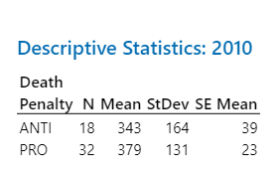**Section 4: Results**

Figure 1: 2010 Results

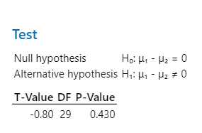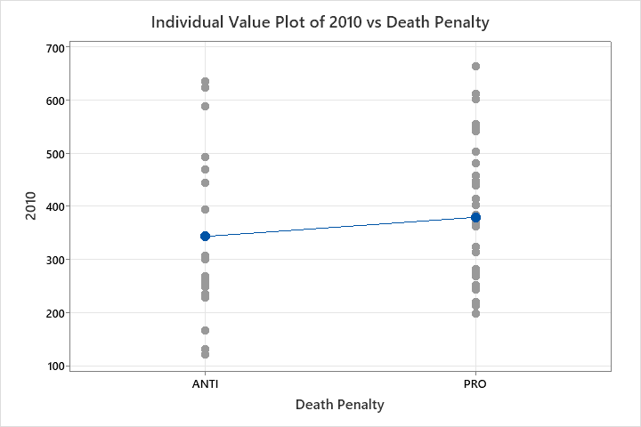

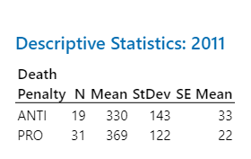

Figure 2: 2011 Results

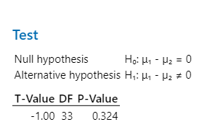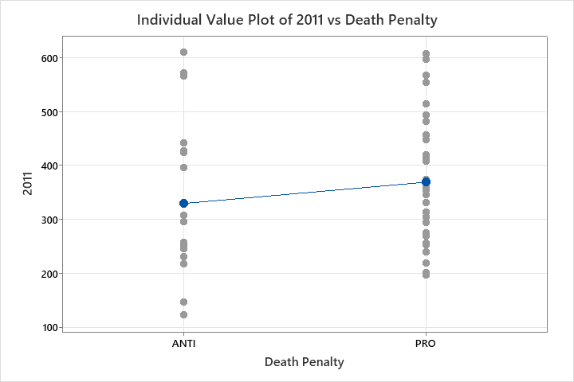

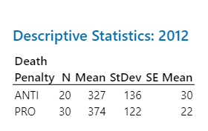Figure 3: 2012 Results

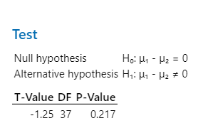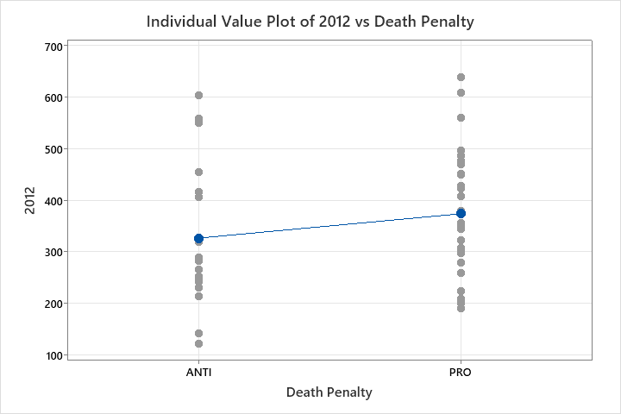

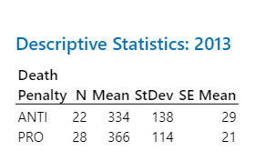Figure 4: 2013 Results

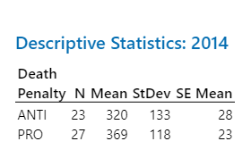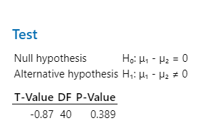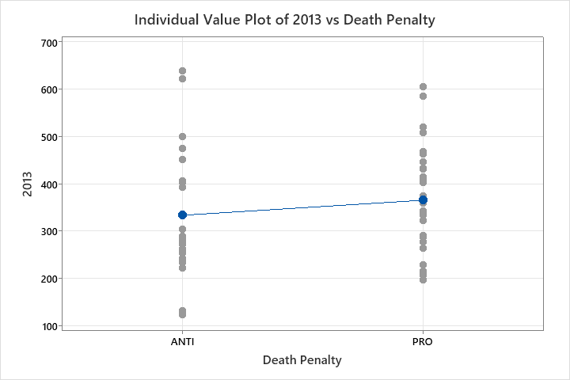

Figure 5: 2014 Results

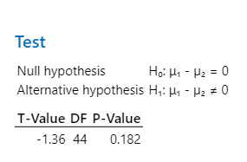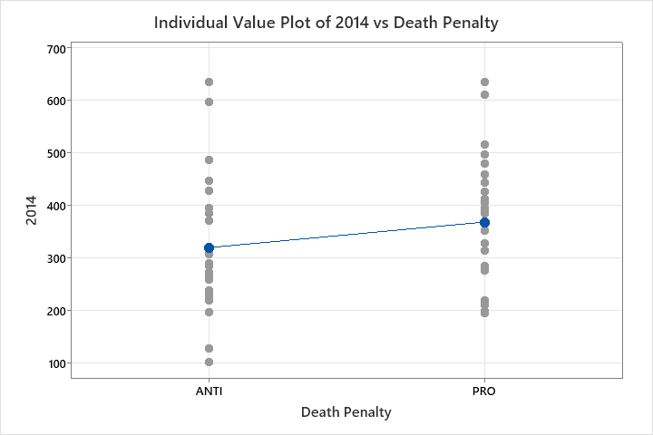

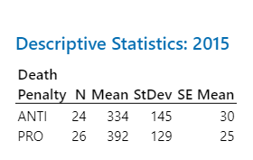Figure 6: 2015 Results

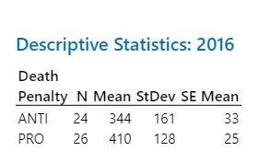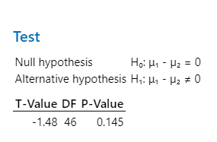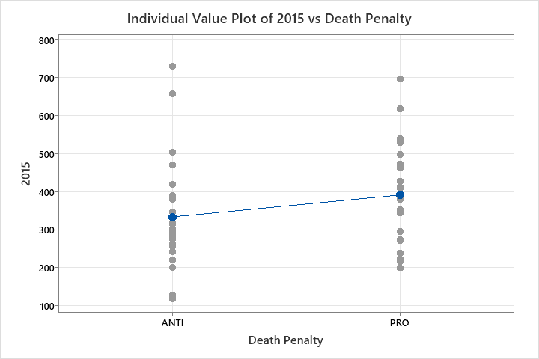

Figure 7: 2016 Results

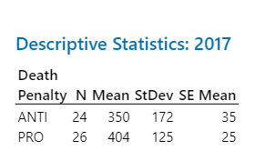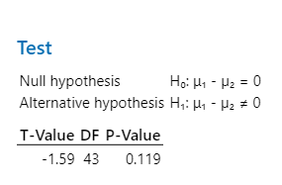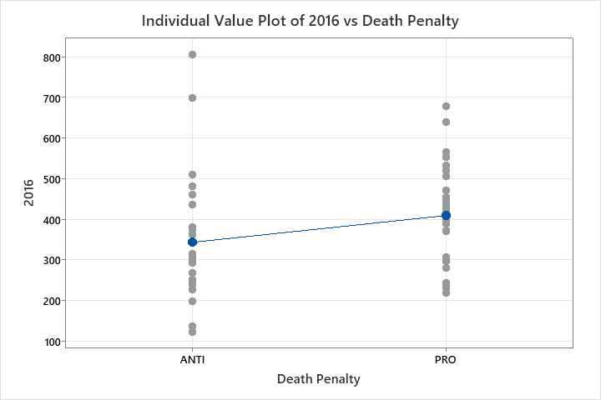

Figure 8: 2017 Results

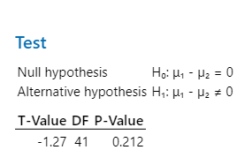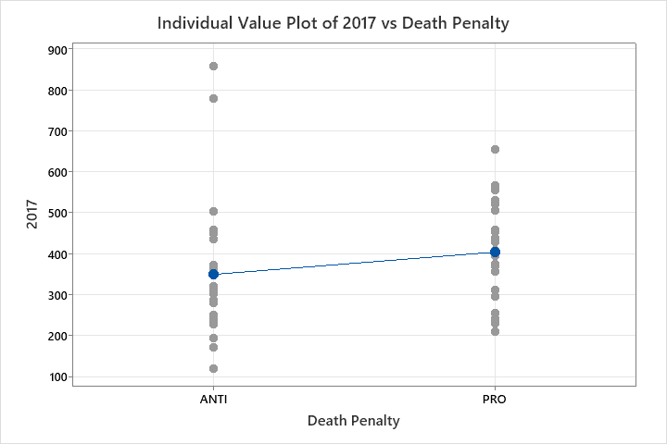

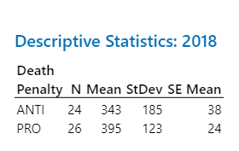Figure 9: 2018 Results

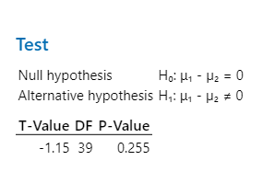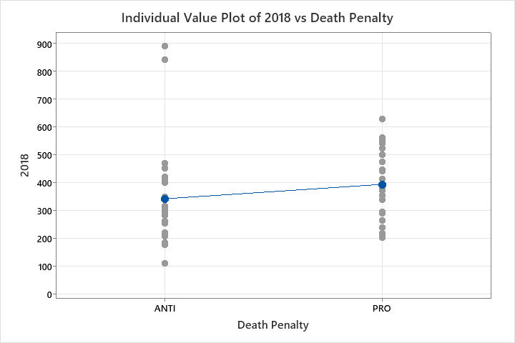

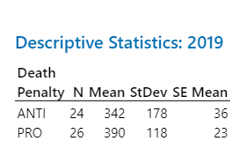Figure 10: 2019 Results

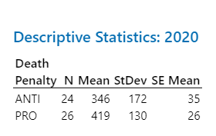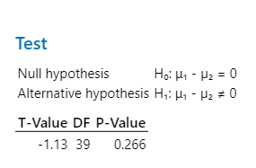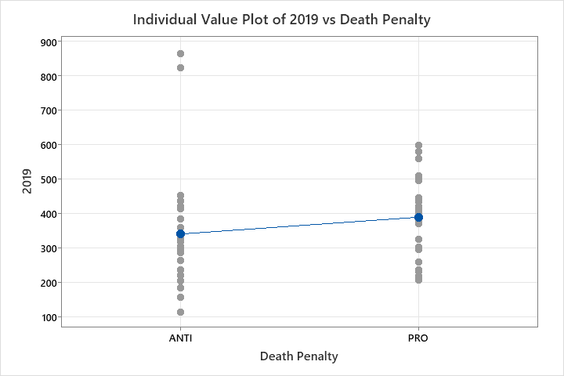

Figure 11: 2020 Results

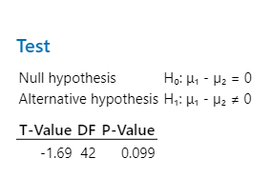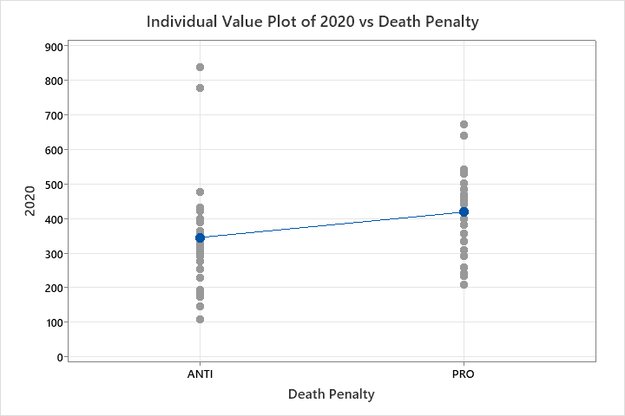

As seen in the results found above, the two sample groups ANTI and PRO capital punishment states can not be dettertmined statistically different in any of the given sample years. There is not a single year in which case the P-value between the two sample groups fell below .05 to deem the two groups statistically different. The P-values of the sampled years ranged anywhere from .430 in 2010 with the highest propobility of corrilation, through .099 in 2020 with the lowest probability of corrilation. Still above the desired .05 threshold however. This ment that we were able to support our original null hypothsis, that the two groups are not significantly different. With the varrying P-scores of every year all above .05, we are at no point able to reject our null hypothesis that the two groups can be deemed statistacally different.

On top of this finding, in all of the studied years the relationship between the the two groups actually found a negative relationship between and PRO capital punishment states and a lower crime rate. Meaning it was actually the ANTI capital punishement states that consistently had lower violant crime rates. Every examined year saw the PRO capital punishment states’s mean crime rate actually be higher than the ANTI’s mean crime rate. This was a very suprsing discovery as it ment that capital punishement was actually not likely a contributing factor in dettering violant crime. In order to further examine this notoin we set up and ran the test a second time, only this time with a hypotheszied difference of 100 less crimes being commited in PRO capital punishment states than in ANTI. If proven true, then we could conclude that PRO capital punishment states do infact lower crime rates by a rate of 100 by 100,000 people per year, or a 26% decrease in crime compared to the US yearly average. Results to how these numbers were calculated are shown below in Figure 12, and the results to the second null hypothesis testing are shown on the following page, page 9.

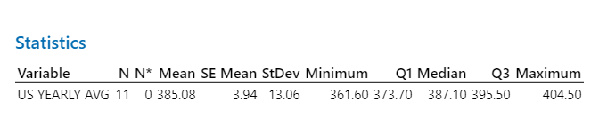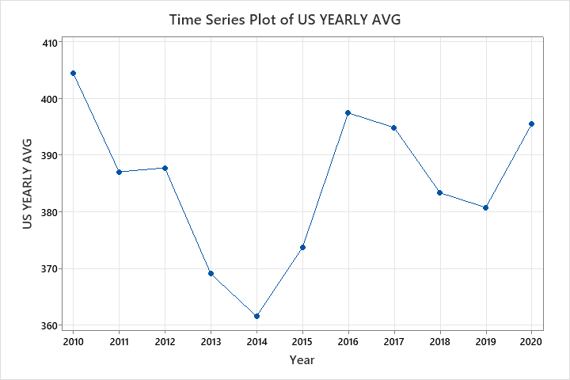Figure 12: US Yearly Avg. Crime Rate

100 / 385.08 = .2596 or 25.96% of total average crime commited

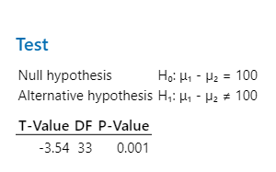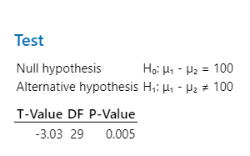2010 2011

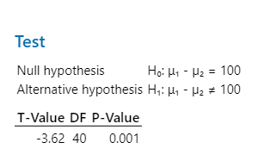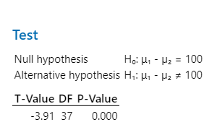2012 2013

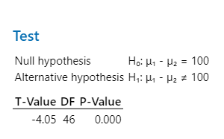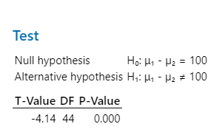2014 2015

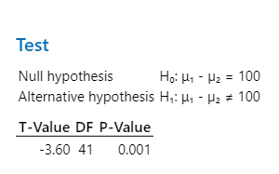2016 2017

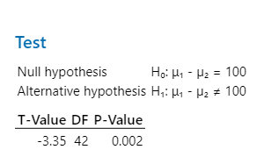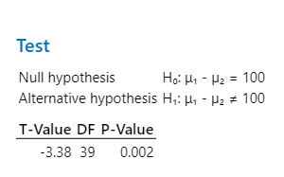2018 2019

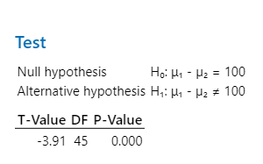

2020

As seen in these results, there is at no point amongst the 11 years studied a time at which the P-Value is above .05 in order for us to say that there is a chance that the null hypothesis may be true. Because of this, we are able to reject the null hypothesis with 95% certainty and say that

“Null Hypothesis (H0): States where capital punishment is being actively sentenced and enforced within the past ten years, see at least a rate of 100 lesser violent crimes (as defined by the FBI) being committed when compared to non-enforcing capital punishment states.”

is statistically not true. There is simply way too low of probable chance for this notion to be true after running the Two Sample T-test that we can confidently reject this null hypothesis.

Now that we have disproven the idea that capital punishment lowers a state’s violent crime rate by 100 offenses per 100,000 people, we are going to run a regression analysis in order to see how much the two variables are correlated in the first place. This regression analysis will be able to determine how much a states capital punishment stance has an efffect on the state’s violant crime rate. We will run the regression analysis for the most recent year of the study (2020) in order to get most current results. This means the regresion anaylisis will be between crime rates in 2020 versus the grouping of the states being either PRO or ANTI capital punihsment. The results to that this regression analysis are shown below in Figure 13 and will tell us much a state’s use of the death pentaly matters in determining their crime rate.

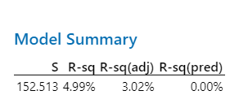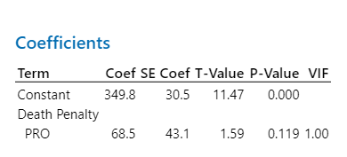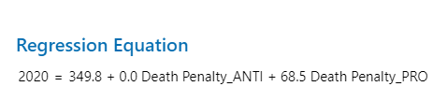Figure 13: Regresion Analysis 2020 vs. Death Penalty Group

The results from the regression analysis found that a state’s capital punishment stance and it’s corisponding violant crime rates were only 4.99% corrilated. This is very low level of corrilation as it means that the other 95% is contributed from some other factors. In fact our 4.99% is just under our .05 threshold to where we are actaully able to say that this amount is statiscally insignificant. This small corrilation that does exist is likely to just be the result of an indirrect corilation between other factors that effect states, and their corrisponding crime rates. Things such as geographical location, population size, average income, GDP, and political tendencies, all would likely play some sort of role in determing a states crime rate. Whether the state is activily using capital punishment or not is most likely more of a lagging factor based of the other 95% of causes to that specific corrilation. As it is below that 5% mark, we will conclude that corrilation between the two is statistically insignicant.

**Discusion and Conclusion**

As earlier stated, the importance of understanding the impact of capital punishment and its effects on society are crucial to policy making. When looking at whether capital punishment should be in place or abolished, one of the factors that should be considered is whether or not it would lower violent crime rates. That is exactly what this whole study is attempting to discover. In order to do so, we collected the crime rates of every state from Federal Bureau of Investigation reports, and then identified each state as being either a PRO or ANTI capital punishment. We took these two groups across all the examined years and ran multiple Two Sample T-tests in order to see what the relationship between the two was.

After running all the Two Sample T-tests for every year and hypothesis, we are able to state with 95% confidence that the two sample groups, PRO vs. ANTI, can not be determined statistically different. They did not obtain a P-Value score of less than .05 in any of the given years and therefore we could not reject our original null hypothesis. However, we can state with 95% confidence that PRO capital punishment states did not statistically have lower crime rates by a value of 100 per 100,000 people versus ANTI capital punishment states. For this reason, we had to reject our second null hypothesis and conclude that that PRO capital punishment states did not have statistically lower crime rates like originally predicted.

This was in fact the major discovery found while doing our study, as it means that despite the two groups not being able to be proven statistically different, it was quite easy to statistically prove that PRO states do not have lower crime rates than ANTI capital punishment states. This notion really eliminates the idea that capital punishment can be used as a way of lowering crime rates in one’s state. In fact, we actually found there to be a slight, but consistent, negative relationship between PRO states and lower crime rates. It was actually the ANTI states that averaged the lower crime rate across all the sampled years. This does not mean that we are concluding that removing capital punishment reduces crime rate however.

As seen by our last test run, the regression analysis between 2020 crime rates and state’s capital punishment groupings, we only achieved a R squared value of 4.99%. This means that the relationship between crime rates and a state’s capital punishment stance is very insignificantly correlated. Because of such a weak correlation value between the two variables, we can confidently say that there are other more statistically important variables out there.

In conclusion, the relationship between a state’s crime rate and its stance as either a PRO or ANTI capital punishment state can not be proven statistically different. The state’s stance as being in either group does not have a proven statistical difference on the value of their crime rate. It can be stated with 95% confidence though, that PRO capital punishment states do not have statistically lower crime rates than ANTI states by equal to, or greater than, 100 out of 100,000 people per year. Disproving the notion that PRO capital punishment states have lower crime rates and allowing us to reject our second null hypothesis. Lastly the two variables have also been proven to be insignificantly correlated, as after running our regression analysis we have found only a 4.99% correlation value. This means that the relationship between a state’s crime rate and whether or not they are actively using capital punishment, is not well correlated in the first place, and should not be used by public officials as a way of attempting to lower crime rates or deter crime. Capital punishment, and the implications of it, is an important matter that has many important points that need to be thought of in the decision to implement it or not. The one thing this study has found however, that should be noted for the debate, is that the use of capital punishment does not cause there to be a statistically significant difference in crime rates, and certainly has not proved to deter more crime from occurring than in non-actively using capital punishment states.

Work Cited

“Federal Bureau of Investigation Crime Data Explorer .” *Crime*, https://crime-data-explorer.app.cloud.gov/pages/explorer/crime/crime-trend.

“State by State.” *Death Penalty Information Center*, https://deathpenaltyinfo.org/state-and-federal-info/state-by-state.